A researcher is interested in determining the effects of different doses of a dietary supplement on a physical endurance test in both males and females. The three different doses of the medicine are (1) low, (2) medium and (3) high and the genders are (1) male and (2) female.
He assigns 48 people, 24 males and 24 females to one of the three levels of the supplement dosage and gives a standardized physical endurance test. Using technological tools, we generate the following summary ANOVA table

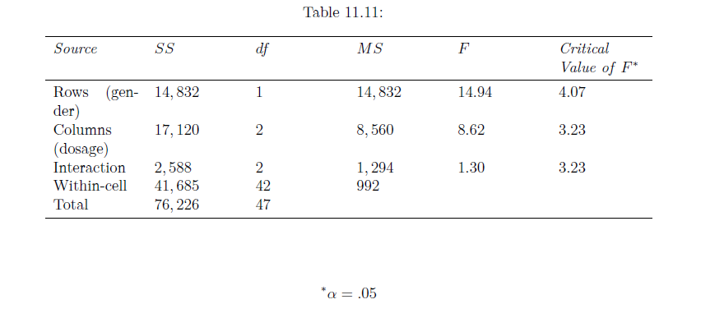
4. What are the three hypotheses associated with the two-way ANOVA method?
5. What are the three null hypotheses?
6. What are the critical values for each of the three hypotheses? What do these tell us?
7. Would you reject the null hypotheses? Why or why not?
8. In your own words, describe what these results tell us about this experiment.

